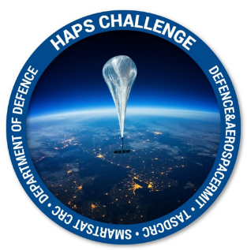
HAPS Challenge
Application Form Part B

Instructions

Please refer to the Guidelines on the Sir Lawrence Wackett Defence and Aerospace Centre website https://www.rmit.edu.au/defence-aerospace/haps-challenge before completing this application. Applications that do not meet the eligibility criteria set out in the Guidelines will not be considered.

You must complete all sections of the application. Your application should consist of the following documents, all available at the website above:
- Application Form (Part A)
- Proposal Details (Part B – This Form)
- Quad Chart (Part C)
The body of your application, the proposal section, must be no longer than 3 pages and be typed in Ariel 12-point font with single spacing using the supplied template. Text in square brackets is to be erased prior to submission.
Use clear, concise language. Avoid jargon and uncommon acronyms.
Do not include this instructions page in your submission.
Applications are to be submitted in both PDF and Word format. Submit Application Forms Part A, Part B and Part C Quad Chart to HAPS.Challenge@tasdcrc.com.au by 24th May 2021.
Date:
Application is for (choose one only) | Stream 1  Automated or Autonomous HAPS Platform Station-keeping and Constellation Maintenance | Stream 2  Automated or Autonomous Attitude Determination and Correction of payload platform
Project title:
Supporting Documents Supplied: | Yes No
Supporting Document File Name:

Detailed Proposal (3 Pages Max)

