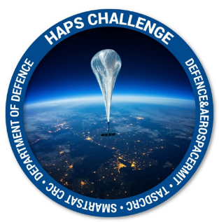
HAPS Challenge
Information for Applicants

Stream 2 Intellectual Property (IP) principles are;

- Phase 1 – applicants in Phase 1 will continue to own the copyright and intellectual property in their submission
- Phase 2 – applicants in Phase 2 will continue to own the copyright and intellectual property in their submission; however, will be required to provide a license to Defence for Defence and National Security purposes
- Phase 3 - It is intended that the project parties will enter into a discussion with SmartSat on the ownership and utilisation of the Project IP prior to the Phase 3 project commencing.
- Recognising that SmartSat is a collaborative organisation, and multi-party/collaborative projects are expected, this also involves multi-party expectations on IP ownership and utilisation.
- The IP discussion takes into consideration the needs of the project parties to support utilisation and commercialisation of the IP.
- Other issues are also considered as part of this discussion, including but not limited to:
• The needs of Start-ups (i.e., needing to own IP for VC fundraising);
• the Background IP that is brought to the project (i.e., a project that is improving Background IP); and
• Defence and National Security requirements.
- As a general starting point for the discussion, SmartSat will propose that the IP arising from the Project can be owned by SmartSat and licensed to the Industry partner(s) to support utilisation.
- This is a starting point for the discussion only, and the final position will be agreed between SmartSat and the project parties.

Contact for Enquiries: HAPS.Challenge@tasdcrc.com.au

