Incident Details:
Event Title:
Event Date: | Click here to enter a date. |  | Event Time: |  |  |  |  | Event Number:
Event Type:  (Select all as appropriate) | ☐ Injury | ☐ Regulatory Notice |  |  |  |  | ☐ Hazard |  | ☐ Complaint | ☐ Security
 | ☐ Near Hit | ☐ Environmental Impact |  |  |  |  | ☐ Damage/Loss |  | ☐ Journey Incident | ☐ Report Only
Name of Injured Person: |  |  |  |  |  |  | Name of Witness/s:
Injured Person:  If injury was sustained | ☐ RMIT Staff |  |  | ☐ Contractor |  |  | ☐ Student |  | ☐ Other:
Campus: | ☐ City | ☐ Bundoora |  |  | ☐ Brunswick |  | ☐ Other:
Location:
(Building/Level/Room No.)
Event Description:
Immediate Actions Taken:

Risk Rating (refer to Appendix 1 – HSW Risk Score Matrix):
ACTUAL Risk Rating:
Consequence: |  |  | Likelihood:
POTENTIAL Risk Rating:
Consequence: |  |  |  | Likelihood:

Data Collection
Mark “NA” in each section that is not applicable.
Gather as many relevant facts as possible so as to understand the incident and the event leading up to it.
Depending on the type of event, not all data collection questions will be applicable.
People Factors | What are the skills/licences required for the job and do they have these?
 | What level of supervision is provided?
 | What was their alertness at the time?
 | What were they doing at the time?
 | How often do they do this (times/day, times/hour)?
 | Who else was involved?
 | Other comments

Environment Factors | What were the weather conditions?
 | Were any housekeeping issues involved (cleanliness)?
 | What were the workplace conditions (work surfaces, work space)?
 | What surrounding noises were present?
 | What were the lighting conditions?
 | Were toxic or hazardous gases, dust or fumes present?
 | Other comments

Equipment Factors | Describe the equipment involved?
 | Was the equipment fit for purpose?
 | Is it regularly inspected/serviced? (date of last inspection/service)
 | Was it functioning correctly?
 | Were hazardous substances involved?
 | What identification labels/safeguards did the equipment/materials have?
 | Were any alternative equipment/materials available?
 | What personal protective equipment was being used?
 | Other comments

Procedures Factors | What work procedure was used?
 | What risk assessment was conducted as part of the planning prior to the task (Prestart, SWMS etc.)?
 | What controls were implemented to mitigate the hazard/s
 | Were personnel trained/ familiar with the procedure/risk assessment?
 | What conditions had changed that would affect the way the normal procedure worked?
 | Other comments

Organisation Factors | What applicable safety rules were communicated to staf/students and when?
 | What written procedures were available?
 | How are the procedures enforced?
 | What supervision was in place?
 | What training was given?
 | How were hazards identified?
 | How were unsafe conditions corrected?
 | Were regular safety inspections carried out?(date of last inspection)
 | Other comments

Data Analysis
What were the ‘last minute measures’ that did not prevent the incident or mitigate/reduce its consequences
What were the actions or inactions that lead directly to the incident?
What where the environmental conditions that may have contributed?
What organisational aspects have allowed the incident or accident to happen (leadership, supervision, training, procedures)?

Preventative Actions
For each above Contributing Factor, list an action that will prevent reoccurrence
Ref No. | Action Description | Hierarchy of Control Type |  | Responsible Person | Due Date
 |  | ☐1.Elimination  ☐2.Substitution  ☐3.Isolation | ☐4.Engineering  ☐5.Administration  ☐6.PPE
 |  | ☐1.Elimination  ☐2.Substitution  ☐3.Isolation | ☐4.Engineering  ☐5.Administration  ☐6.PPE
 |  | ☐1.Elimination  ☐2.Substitution  ☐3.Isolation | ☐4.Engineering  ☐5.Administration  ☐6.PPE
 |  | ☐1.Elimination  ☐2.Substitution  ☐3.Isolation | ☐4.Engineering  ☐5.Administration  ☐6.PPE
 |  | ☐1.Elimination  ☐2.Substitution  ☐3.Isolation | ☐4.Engineering  ☐5.Administration  ☐6.PPE

Consultation
Have key stakeholders’ been updated of investigation outcome?
Name: |  | ☐ Select when consultation is complete
Position:
Date:
Name: |  | ☐ Select when consultation is complete
Position:
Date:

Acknowledgement
Name | Position | Date | Signature

Appendix 1 – HSW Risk Score Matrix
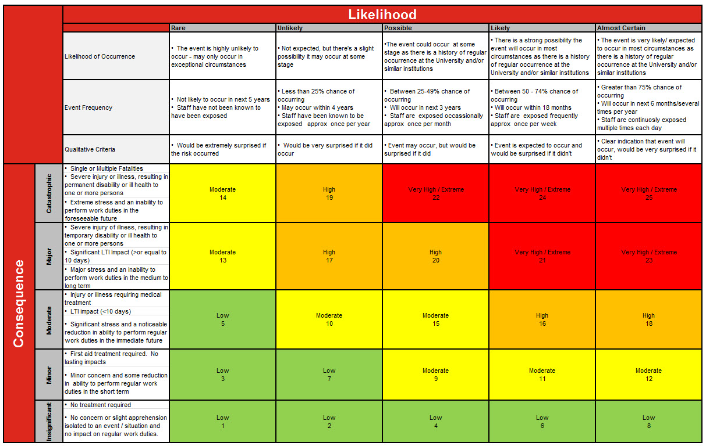
Please Note: 1. ALL risks must be reduced to as low as reasonably practicable . 2. If the residual risk is High or Very High / Extreme, the activity is not to proceed until higher level controls are in place 3. Residual Risks that are Moderate must be signed off by the responsible/accountable Manager

