STAFF DETAILS
Name |  | Supervisor
College / Portfolio |  | School / Department
Location |  | Date

Ergonomic Principles |  |  |  | Yes | No
1 | Is the surface of the desk at or slightly below your elbow height? (refer to diagram “a” below)  * If the desk is not adjustable, the chair height should be adjusted, and a footrest may be required. |  |  | ☐ | ☐
2 | Is your chair height adjusted so that your feet are comfortably flat on the floor (or footrest) and your seat pan is positioned so that your hips, knees and ankles are at a 90-degree angle (refer to diagram “a” below)  *A footrest may be required. |  |  | ☐ | ☐
3 | Is the chair backrest adjusted to fit the small of your lower back and so that you sit upright whilst typing? (refer to diagram “a” below) |  |  | ☐ | ☐
4 | When you are seated in the chair, are there 2-3 finger spaces between the back of the knee and the edge of the seat pan?  * If there is less than 2 fingers gap or more then 8-10cm gap, adjust the seat slider function to move the seat pan forward or backwards. |  |  | ☐ | ☐
5 | Is your computer (including keyboard and screen) positioned directly in front of you to minimise unnecessary twisting or stretching? |  |  | ☐ | ☐
6 | Is the height of your computer screen positioned so that the top of the screen is level with, or slightly lower than your eyes? (refer to diagram “c” below) |  |  | ☐ | ☐
7 | Is the screen positioned at approximately an arm’s length away from your usual seated position?  *Adjust your screen so that it is positioned one arm’s length away. |  |  | ☐ | ☐
8 | Is the screen positioned to avoid glare/reflection from windows and overhead lights?  *If the screen cannot be repositioned, a glare guard may be required. |  |  | ☐ | ☐
9 | Do you use dual monitors?  *If you use dual monitors frequently, position monitors side-by-side with the monitor edges touching and the split directly in front of your body to avoid twisting. |  |  | ☐ | ☐
10 | Do you regularly use a laptop?  *If “YES” you will need to organise a laptop stand or docking station with a separate keyboard and mouse AND start at the beginning of this checklist to make sure your equipment is set up safely. |  |  | ☐ | ☐
11 | Is the keyboard positioned so that it is close to the front of the desk? |  |  | ☐ | ☐
12 | When using the keyboard, are your upper arms and elbows close to the body and your forearms, wrists and hands held straight in a neutral position? (refer to diagram “a” below)  ∗The keyboard feet (located under the keyboard), should be lowered to reduce excessive wrist extension. |  |  | ☐ | ☐
13 | Is the mouse positioned at the same height as the keyboard & close to the keyboard? |  |  | ☐ | ☐
14 | Do your wrists remain in a neutral position when using the mouse?  *Avoid gel wrist rests. Resting on your wrists while typing can compress the blood vessels, tendons, and nerves that travel through your wrist. |  |  | ☐ | ☐
15 | Are documents being referenced placed between the keyboard and screen OR suspended alongside the screen (for single screen only)?  *A document holder may be required if referring to reference material for prolonged periods. |  |  | ☐ | ☐
16 | Are frequently used items (e.g. phone) placed within the optimum to maximum reach sector on your desk/table, and items used less frequently (e.g. in trays) positioned in your outer reach sector? (refer to diagram “d” below) |  |  | ☐ | ☐
17 | Are regularly used resources/folders stored in an easy reach position to prevent overreaching?  ∗ Do not handle heavy items in a seated position. |  |  | ☐ | ☐
18 | When using the phone, do you have to rest it on your shoulder or bend your neck awkwardly to support it?  ∗ A headset may be required for telephone operators/using the keyboard whilst on the phone for continuous long periods of time. Please discuss with your Supervisor |  |  | ☐ | ☐
19 | Are drawer units obstructing your lower limb movement when seated?  * Drawer units should be positioned so they are not obstructing limb movement and are within easy reach without bending or twisting to access them while seated. |  |  | ☐ | ☐
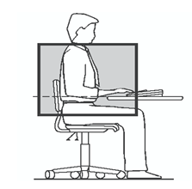 |  | 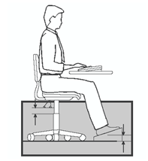 | 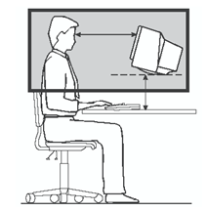
a) Desired sitting position. |  | b) Using a footrest. | c) Desired screen position.
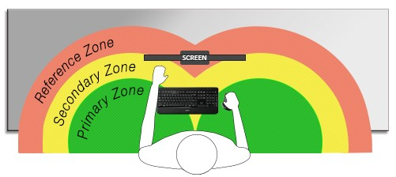
d) Workstation arrangement.

Sit to stand workstation |  | Yes | No
20 | Are your monitor/s elevated/adjusted so that your eyes are positioned in the top third of the screen while standing?  *Your monitor screen height should not need to be adjusted from a sitting to standing position. | ☐ | ☐
21 | Is your keyboard and mouse at the same level and positioned close to your body? (stand close to the sit/stand workstation to avoid leaning forward)  *The desk surface should be raised or lowered so that your elbows are at or slightly above the desk surface. | ☐ | ☐

Immediate action taken for improvement:

