Tiertime Cetus Mk3 3D printer Safe Operating Process
This Safe Operating Process (SOP) is to be used in conjunction with any legislation, operating manuals, Australian or International Standards or task relevant training.
Description of the Work:
Use of the Tiertime Cetus Mk3 3D printer to complete 3D printing projects
Personal Protective Equipment Required: remove any which are not relevant
 | Safety glasses may be required for some operations. |  |  | 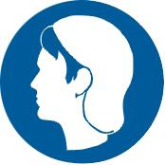 |  | Long and loose hair must be contained.
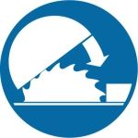 | Safety guard must be used at all times. |  |  | 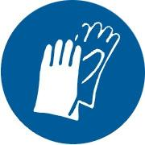 |  | Safety gloves may be required for some operations.
Potential Hazards
- Fumes and particles |  |  |  |  | - Cuts when removing printed objects from the print board
- Burns from hot surfaces - especially the print head nozzle |  |  |  |  | - Particles in eyes when trimming projects
- Pinching from the print fan |  |  |  |  | - Water leaks and electricity. Do not use near any wet surfaces
Pre-Operational Safety Checks:
- Make sure you have completed the 3D printer induction.
- Check the Tiertime Cetus Mk3 is free from of obstructions that may prevent the machine from feeding material smoothly
- Ensure the print board is correctly locked to the print table
- Check that no maintenance tools are present in the UpBox
- Ensure the spool and filament is not an entanglement risk
- Check filament is loaded per instructions? Make sure you are familiar with how to change filament before doing so or ask a MakerSpace technician to assist
- Ensure PLA filament is being used. We only support the use of PLA filament in the Library Makerspace. ABS filament is not to be used in the Library MakerSpace
- Report any suspect equipment to your MakerSpace technician
- Ensure you have the correct PPE - protective glasses, gloves.
Operational Safety Checks:
- Turn on the Tiertime
- Ensure you have elected the correct filament type setting - PLA setting
- Do not move the Tiertime Cetus Mk3 during operations
- Do not initiate movement of the print head whilst any foreign body, clothing, hair, fingers) are close to or entangled in the machine
- Never touch the nozzle, print head or print bed during operations. This could result in burns or other personal injuries
- Never attempt to remove the nozzle from the print head
- Never touch print head, print board or printed parts immediately after print operations as they will be HOT Especially the print head
Post-Operational Safety Checks:
- Turn off the printer before placing your hands in the printer and before removing parts
- Take care when removing material from the 3D printer as the nozzle can be extremely hot - you will need to wear gloves to remove print from print board.
- Wear safety glasses and gloves when removing support material and trimming objects
- Clear workspaces of any residue and debris and place waste in the appropriate bin
Housekeeping:
- Return PPE equipment to storage containers next to the 3D Printers
- Clear workspaces of any residue and debris and place waste in the appropriate bin
- Inform MakerSpace technicians of any problems or faults
Maintenance & Cleaning
Daily
- Clear workspaces of any residue and debris and place waste in the appropriate bin
- Clean print boards
Weekly
- Clean nozzle

Assessed by: |  | Charles Barnett
Date of Assessment: |  |  | 18 July 2018

